Pentagon Study Finds 50% Increase in Reports of Military Sexual Assaults
By HELENE COOPER
MAY 1, 2014
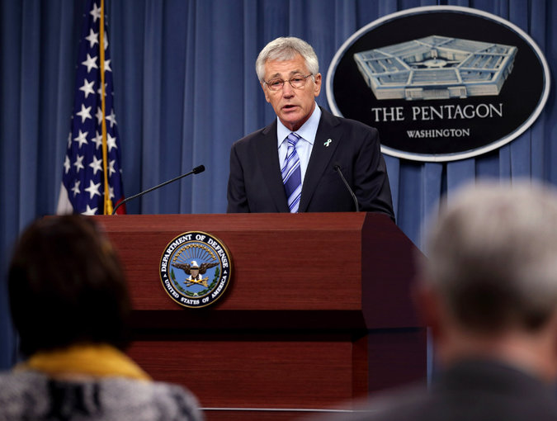
Defense Secretary Chuck Hagel said on Thursday that the results of the Pentagon report showed that though there remains a long way to go, “victims are growing more confident in our system.”
Credit: Chip Somodevilla/Getty Images

WASHINGTON — A Pentagon study released Thursday showed a sharp increase last year in reports of rapes and sexual assault — they were up by 50 percent — but the study immediately came under fire for what critics said were significant limitations.

White House and Defense Department officials characterized the much-anticipated study as a welcome sign that victims are more comfortable reporting assaults and that victims perceive the Pentagon to be taking the problem seriously. But critics of the study said there was no way to know if the increase in reporting meant that there were more sexual assaults over all last year. Unlike in previous years, the study did not estimate how many sexual assaults took place over all last year. In 2012, a confidential Pentagon survey estimated that 26,000 men and women were sexually assaulted. Of those, 3,374 cases were reported.

In contrast, 5,061 cases were reported last year.

Senator Kirsten E. Gillibrand, the New York Democrat who unsuccessfully pushed a bill this year that would have taken the prosecution of sexual assault cases out of the military chain of command, was among the critics of the study.

“Since today’s report does not include a total estimated number of crimes committed, it is impossible to draw any conclusions regarding the number of increased reports,” she said.
Nonetheless, Ms. Gillibrand said the study was a troubling look at sexual assault in the military: The Pentagon said that of the 5,061 reported cases, 484 went to trial, and 376 resulted in convictions. The numbers, she said, “should send chills down people’s spines,” because less than one of 10 reported cases proceeded to trial.

At a Pentagon news briefing on the release of the report, Defense Secretary Chuck Hagel said that “we have a long way to go before we get close to solving this problem.” But he also said that “victims are growing more confident in our system.” Addressing his remarks to military sexual assault victims, he then said that Defense officials “are all listening to you, and we will do everything we can to support you.”

The new statistics show a military struggling to deal with an issue that has gained political attention as more women and men have come forward to say that they do not trust their commanders to properly handle accusations of sexual assault.

Ms. Gillibrand’s attempt to have independent military prosecutors rather than a victim’s commander oversee sexual assault cases failed on March 6, but she came close to garnering the 60 votes needed to move her bill forward. A bipartisan group of senators expressed their own frustration with the military and joined forces with Ms. Gillibrand, among them two Republicans, Senator Rand Paul of Kentucky and Senator Charles E. Grassley of Iowa.

Gen. Martin E. Dempsey, the chairman of the Joint Chiefs of Staff, recently indicated that he is aware that public patience with the military is running out. He told military bloggers last month that “if it occurs that after a period of very intense and renewed emphasis on this that we can’t solve it, I’m not going to fight it being taken away from us.”

Maj. Gen. Jeffrey Snow, director of the Pentagon’s Sexual Assault Prevention and Response Office, went through a list of steps that the Defense Department has taken in recent months to try to fix the system: creating a victims’ program to offer legal consultation, adding methods to assess how military commanders are performing on issues of “dignity and respect,” and instituting a special program to improve collaboration between investigators.

“The system of military justice that we have in place today is significantly different from the one that existed as recently as two years ago,” General Snow said.

He and other Defense Department officials said that although the number of reported sexual assaults had increased, that did not necessarily mean attacks had increased. Pentagon officials said there continued to be a low number of male victims reporting sexual abuse — 14 percent of the reports filed last year came from men.

Officials said they believe that number should be higher because there are far more men than women in the military. But they said that getting more men to report is difficult because many men in the military believe that filing such reports will give the appearance that they are weak, and will set off questions about their sexual orientation.

Representative Niki Tsongas, Democrat of Massachusetts, said the latest numbers possibly signal that recent steps by the military to encourage more reporting is bearing fruit. But she said, “It is incumbent upon the military and its leaders to demonstrate that when these crimes occur, justice is served,” and warned that “the window of opportunity for them to do so is closing, fast.”

